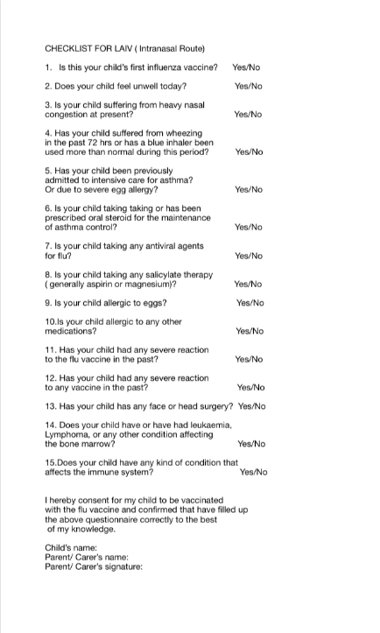
PLEASE COMPLETE THIS FORM AND BRING WITH YOU ON THE DAY YOUR CHILD HAS THE NASAL FLU VACCINE. THIS WILL SAVE TIME AND YOU WILL NOT NEED TO SPEND TOO LONG IN THE ROOM WITH THE NURSE. THIS WILL HELP WITH COVID.

